1 FCK Editor

LAMS2.1.1 authoring tools currently use FCK Editor Version 2.5.1. Build 17566 (Figure 1). The popularity of the FCK Editor is reflected in its number of downloads (i.e. approximately 3 million by August 2008). The Editor is regularly updated and the most up-to-date release as of writing this paper was Version 2.6.3, moreover the FCK Editor Roadmap suggests that Version 3.0 is in the ‘pipeline’. A lengthy list of applications that use the Editor is available on here, a demo of the Editor is accessible on this site, and the FCK Editor’s User Guide is obtainable here.

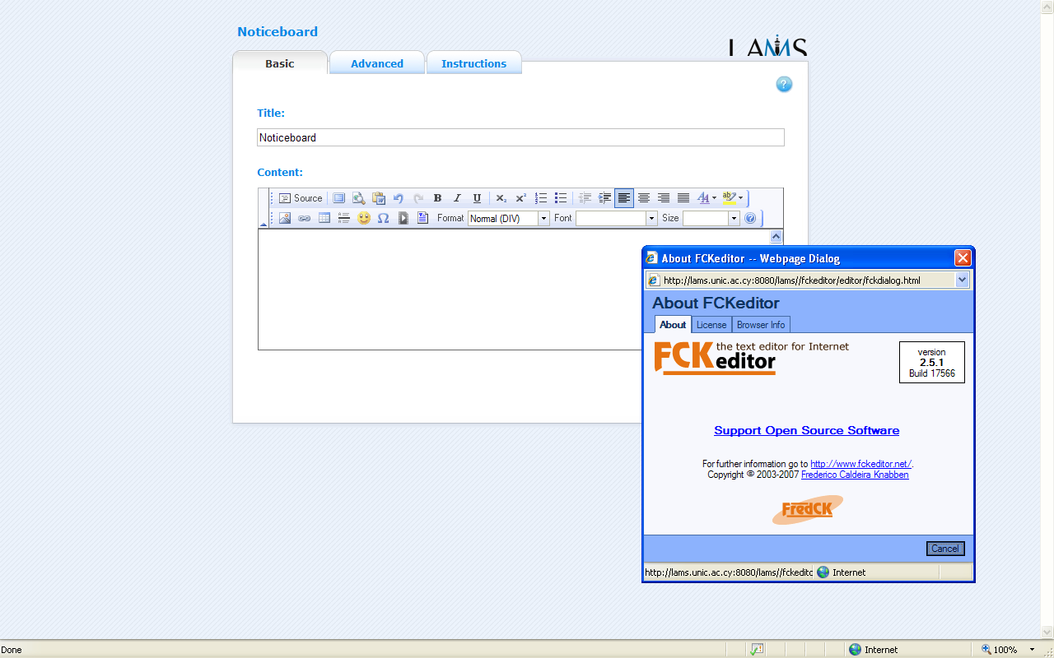
The FCK Editor
FCK Editor Dialogue Box indicates Version 2.5.1 is currently used in LAMS
flvPlayer in LAMS

Figure 1 a screenshot of the FCK Editor

The LAMS Roadmap does not appear to mention that the upcoming LAMS 2.2 and 2.3 versions will have updated FCK Editors. Some of FCK Editor Version 2.6.3 functions could be useful to LAMS users; for instance, ‘spell check’, ‘multi-language support’, ‘style’, a wider variety of ‘paste’ functions, ‘find/replace’. Even though the FCK Editor is on the whole fairly easy to use, this short paper will look at the following more challenging areas: section 1.1 (inserting Google Gadgets), section 1.2 (inserting Images with the FCK Editor), section 1.3 (more advanced insertion of URLs), section 1.4 (more aesthetic presentation of WebPages in LAMS), section 1.5 (tabular embedding of YouTube films), section 1.6 (converting videos of teacher speaking for flvPlayer use in LAMs).

1.1 Google Gadgets

A new feature of LAMS is the ability to include Google Gadgets as part of a LAMS sequence; this presentation shows how this can be done. The screenshots in Figure 2 shows the processes involved in doing this.

Once the Google Gadget has been chosen, the code has to be copied and pasted into FCK Editor

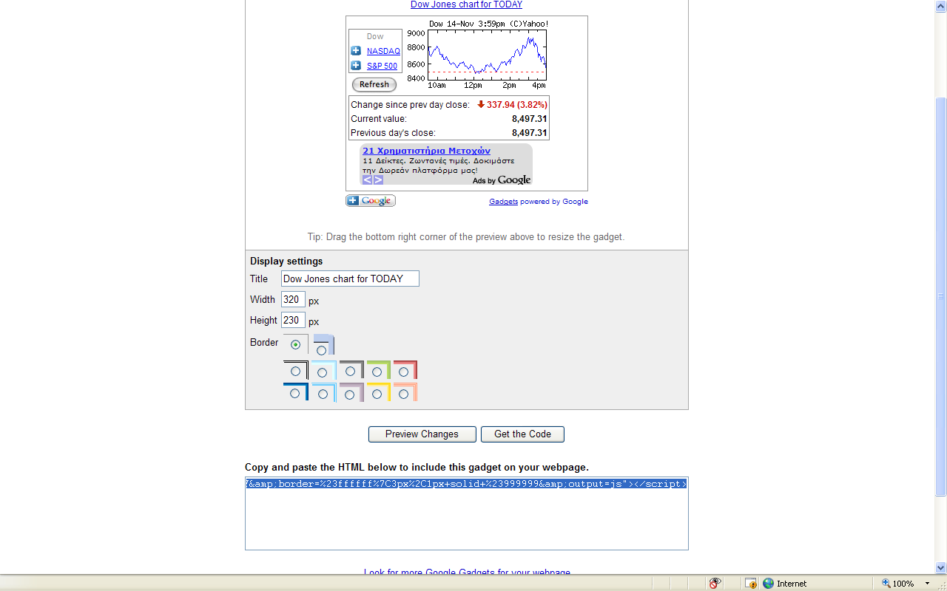
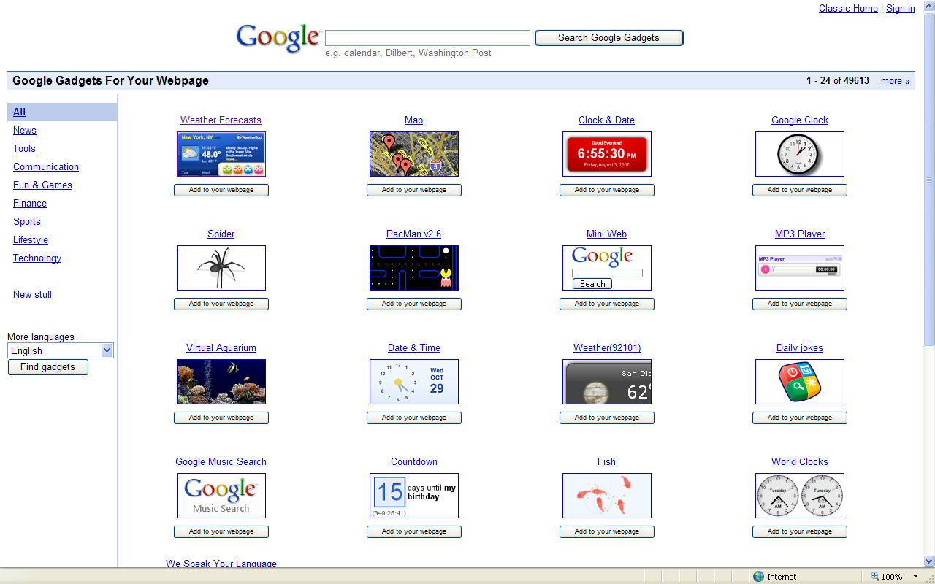

First

Google Gadget code

Second

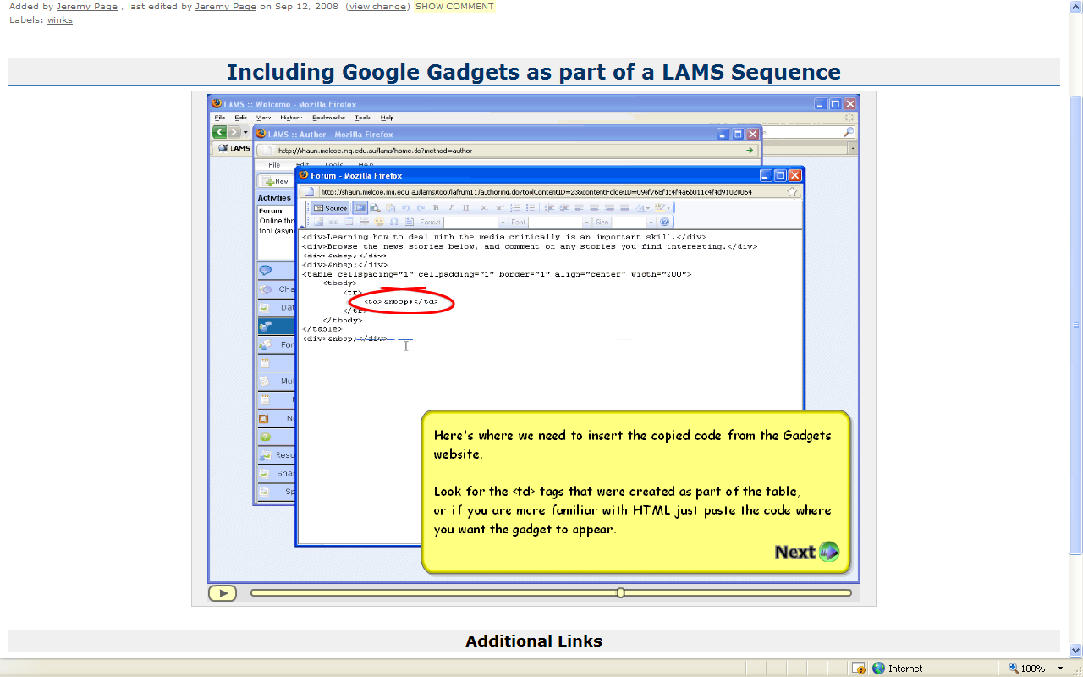
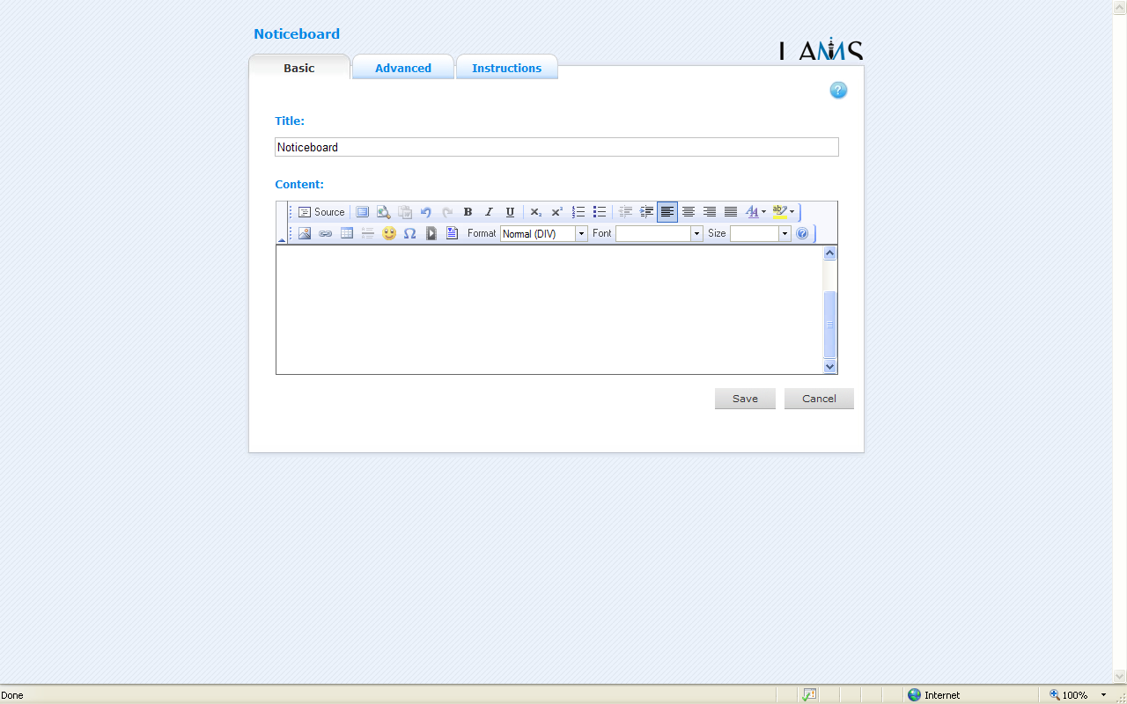

Third

Click ‘Source’ on the FCK Editor
Copy code directly or here if within a table for more aesthetic presentation

Figure 2 Bringing Google Gadgets into LAMS

The Google Gadget code can be pasted straight into the Source on the FCK Editor or as below if in a table.

1. Find this

<td>&nbsp;</td>

2. Delete the code here marked in yellow

<td>&nbsp;</td>

3. Insert Google Gadget code

<td>INSERT GOOGLE GADGET CODE HERE! </td>

EXAMPLE

<td> <script src="http://www.gmodules.com/ig/ifr?url=http://lsmith2004.googlepages.com/aquarium.xml&amp;synd=open&amp;w=320&amp;h=232&amp;title=Virtual+Aquarium&amp;border=%23ffffff%7C1px%2C1px+solid+black%7C1px%2C1px+solid+black%7C0px%2C1px+black&amp;output=js"></script></td>

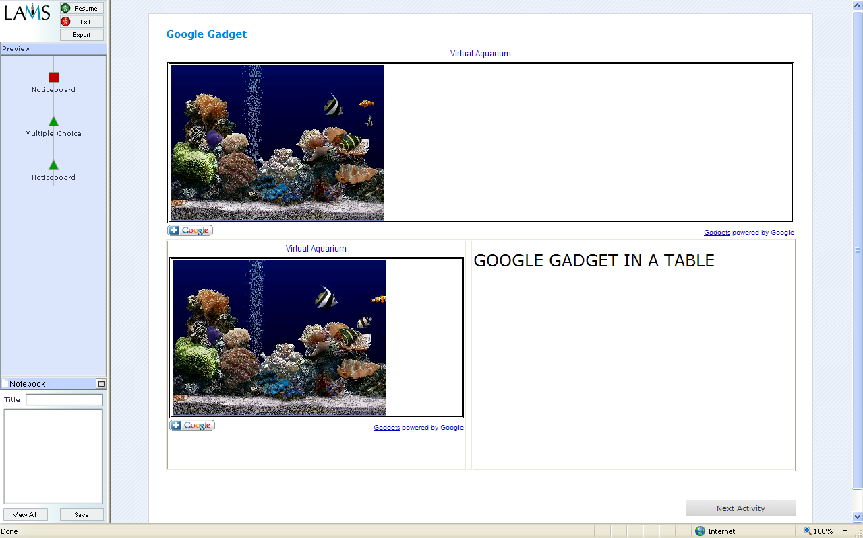
Google Gadget in a table

Figure 3 Google Gadget from the learner’s view

Google Gadgets can enhance the visual appearance of LAMS lessons sequences; the FCK Editor Preview function does not appear to provide ‘trouble-free’ preview of Google Gadgets, however the Gadgets can be viewed from the LAMS Author Learner Preview on the Sequence Management Toolbar

1.2 Inserting Images with the FCK Editor

Information on inserting images with the FCK Editor is available on this site. The icon for inserting image is . Figure 4 provides screenshots of two of its four bookmarks (Image Info, Link, Upload, Advanced). On the whole, inserting images is straightforward, however some parts of this tool’s options have many features and the FCK Editor User Guide does not appear to fully explain advanced usage.

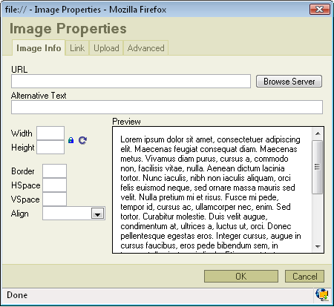
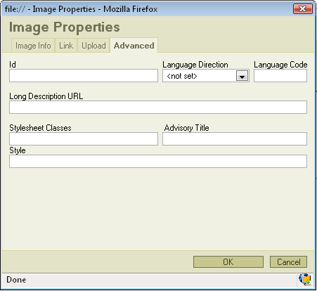

Figure 4 Screenshots of Image Info and Advanced of Inserting Image on the FCK Editor

1.3 Improving appearance of uploaded files in LAMS

The FCK Editor allows documents to be uploaded to a LAMS server; however the presentation of such documents can be improved with the code described in this section (see Figure 5).
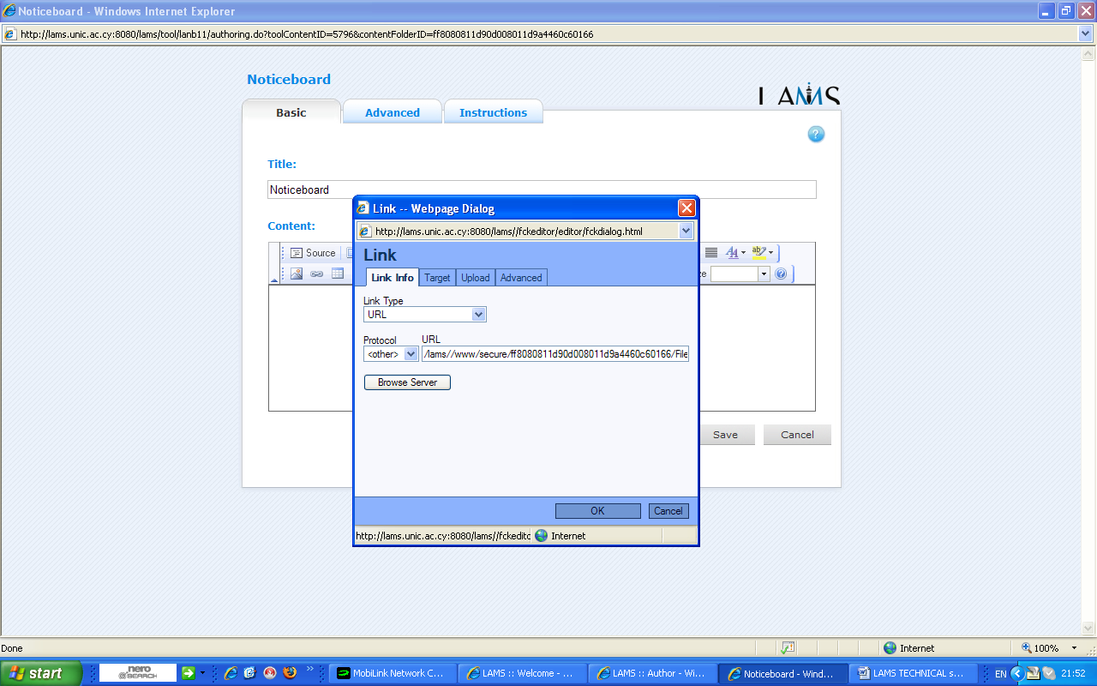
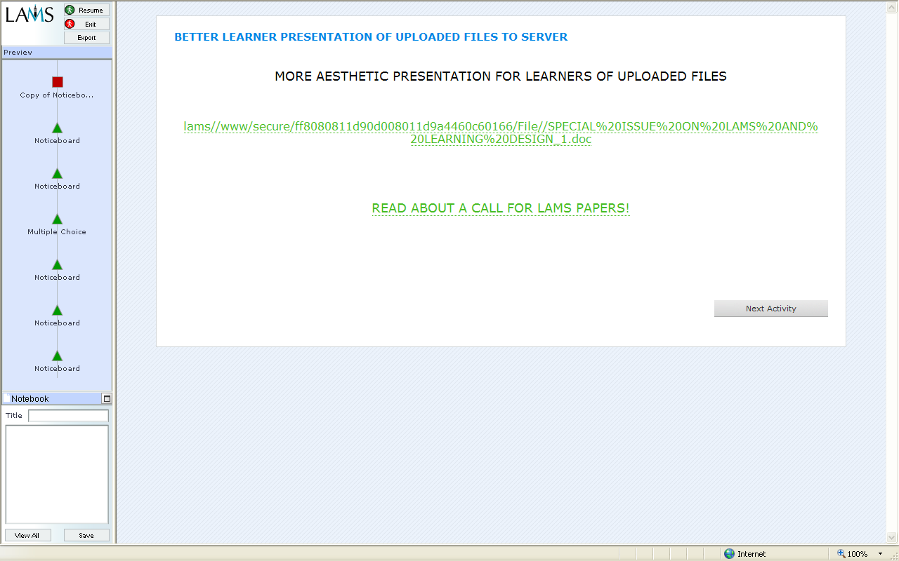
Upload documents here
Less aesthetic ‘code’ form of presentation of link to uploaded document in the Learner environment
More aesthetic text form of presentation of link to uploaded document in the Learner environment

Figure 5 More aesthetic form of presentation of link to uploaded document in the Learner environment

The FCK Editor online manual again provides scant and comparatively specialised reading about this ‘Link’ function (see here). The code to be used in Source to replace the less aesthetic code form with a chosen text form is described below.
- First go to the Source on the FCK Editor.
- Notice the URL is repeated (here the URL of the uploaded document is lams//www/secure/ff8080811d90d008011d9a4460c60166/File//SPECIAL%20ISSUE%20ON%20LAMS%20AND%20LEARNING%20DESIGN_1.doc.
- Delete the repeated version (i.e. the yellow version)

<div style="text-align: center"><span style="font-size: medium"><a target="_blank" href="/lams//www/secure/ff8080811d90d008011d9a4460c60166/File//SPECIAL%20ISSUE%20ON%20LAMS%20AND%20LEARNING%20DESIGN_1.doc">lams//www/secure/ff8080811d90d008011d9a4460c60166/File//SPECIAL%20ISSUE%20ON%20LAMS%20AND%20LEARNING%20DESIGN_1.doc</a></span></div>

- Replace it with your chosen text (i.e. the purple text below)

<div style="text-align: center"><span style="font-size: large"><span><a target="_blank" href="/lams//www/secure/ff8080811d90d008011d9a4460c60166/File//SPECIAL%20ISSUE%20ON%20LAMS%20AND%20LEARNING%20DESIGN_1.doc">READ ABOUT A CALL FOR LAMS PAPERS!</a></span></span></div>

1.4 More aesthetic presentation of WebPages in LAMS

Utilising WebPages within LAMS undoubtedly enhances its learning capabilities. This section describes three advanced ways of using Source on the KFCEditor to improve the visual presentation of Web links: (i) a chosen text that links to a WebPage in a separate window; (ii) WebPages a la ‘Fancy Noticeboard’; (iii) a chosen text that links to a WebPage in the same window. Figure 6 presents a screenshot of a chosen text that links to a WebPage in a separate window

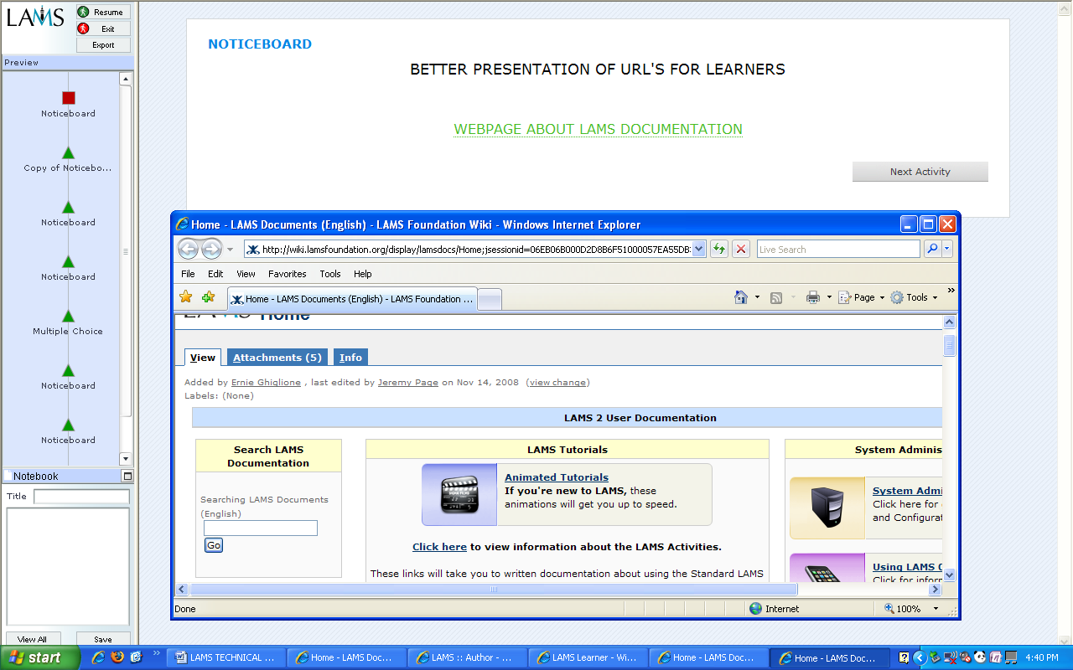
Chosen text

Separate WebPage on LAMS Documentation

Figure 6 Chosen text that links to a WebPage in a separate window

This is done by using the code below; note the yellow and grey parts are the most important sections to change, the rest can stay the same.
Text alignment
Font size
Put URL here

<div style="text-align: center"><span style="font-size: medium"><a target="_blank" href="PUT WEBPAGE HERE">PUT WHAT YOU WANT THE LEARNER TO SEE HERE </a></span></div>

Put Learner text here

FIGURE 6 SOURCE CODE: LAMS DOCUMENTATION PAGE http://wiki.lamsfoundation.org/display/lamsdocs/Home;jsessionid=06EB06B000D2D8B6F51000057EA55DB3

KEEP THE REST THE SAME APART FROM THE COLOURED SECTIONS

<div style="text-align: center"><span style="font-size: medium"><a target="_blank" href=" http://wiki.lamsfoundation.org/display/lamsdocs/Home;jsessionid=06EB06B000D2D8B6F51000057EA55DB3 ">WEBPAGE ABOUT LAMS DOCUMENTATION</a></span></div>

- WebPages a la ‘Fancy Noticeboard

Importing WebPages into LAMS is extremely useful, sophisticated and visually enhancing function. Figure 7 provides screenshots of how this is done and what this looks like.

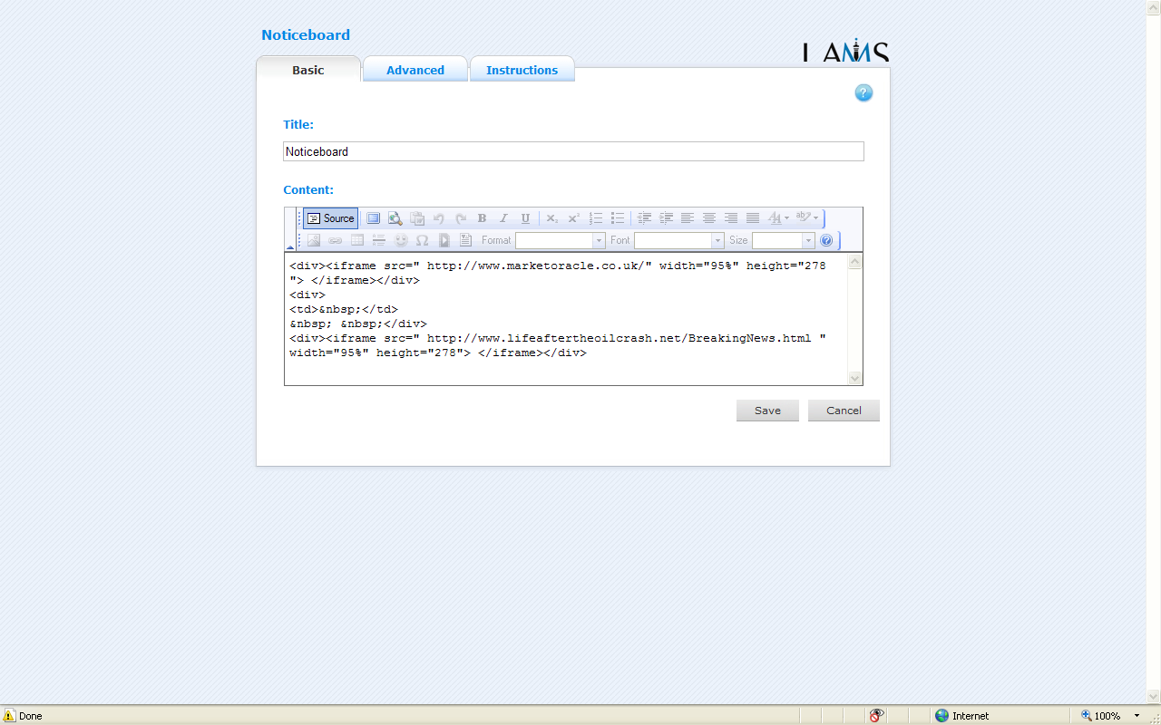
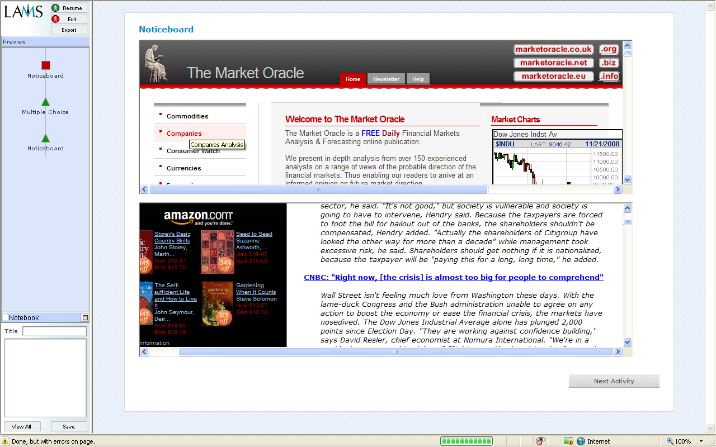

Paste code for WebPages in ‘Source’ on the FCK Editor

Learner view of 2 WebPages

Figure 7 Inserting WebPages a la ‘Fancy Noticeboard’

This is done by using the code formula below; note the size can be adjusted by changing the numbers in yellow in box 1 below (i.e. just change the yellow parts, keep the rest the same!)

BOX 1

<div><iframe src=" PUT URL HERE" width="95%" height="278"> </iframe></div>

To achieve the Learner view of the two WebPages presented in Figure 7 the codes below in Box 2 were copied and pasted into Source in the FCK Editor

BOX 2

<div><iframe src="http://www.marketoracle.co.uk/" width="95%" height="278"> </iframe></div>
<td>&nbsp;</td> (this puts a space below, the WebPage)
<div><iframe src=" http://www.lifeaftertheoilcrash.net/BreakingNews.html " width="95%" height="278"> </iframe></div>

This kind of usage could be useful for chat/forum activities where students can access a WebPage directly and still view the chat/forum contents.

- A chosen text that links to a WebPage in the same window (Figure 8)

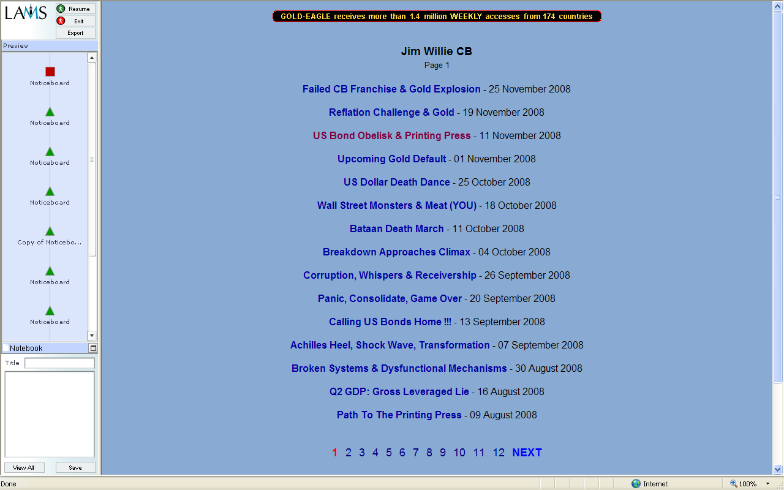
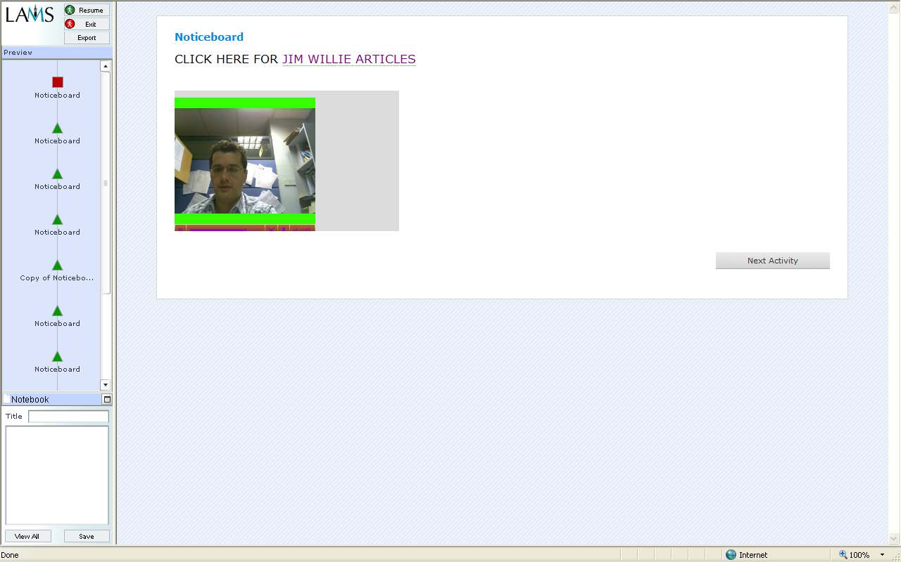

Chosen text that links to URL on the same page
FULL VIEW: Possibly more learner friendly use of WebPages

Figure 8 Inserting chosen text that links to a WebPage in the same window

Put chosen non interactive text here
Put chosen interactive text here
Put URL here

<div style="background: white; margin: 4.8pt 0cm 6pt; line-height: 18pt"><span style="font-size: 12.5pt; color: black">CLICK HERE FOR <a href="http://www.gold-eagle.com/research/williendx.html"><font color="#800080">JIM WILLIE ARTICLES</font></a></span></div>
</span></div>

1.5 Embedding YouTube films using the FCK Editor (Figure 9)

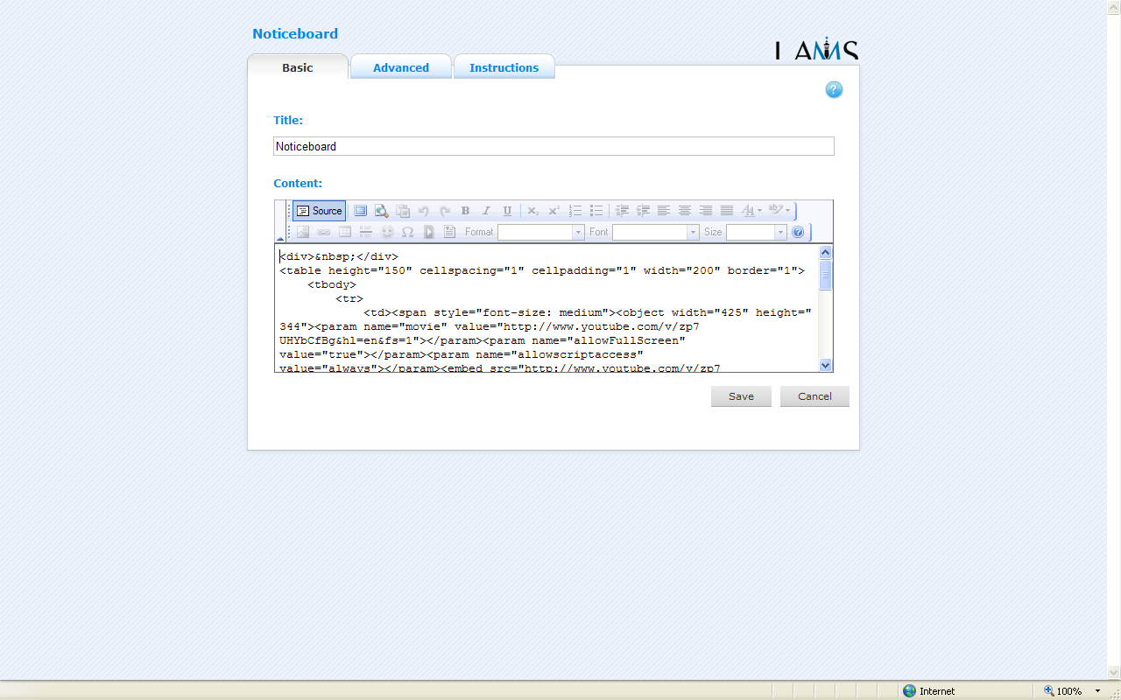
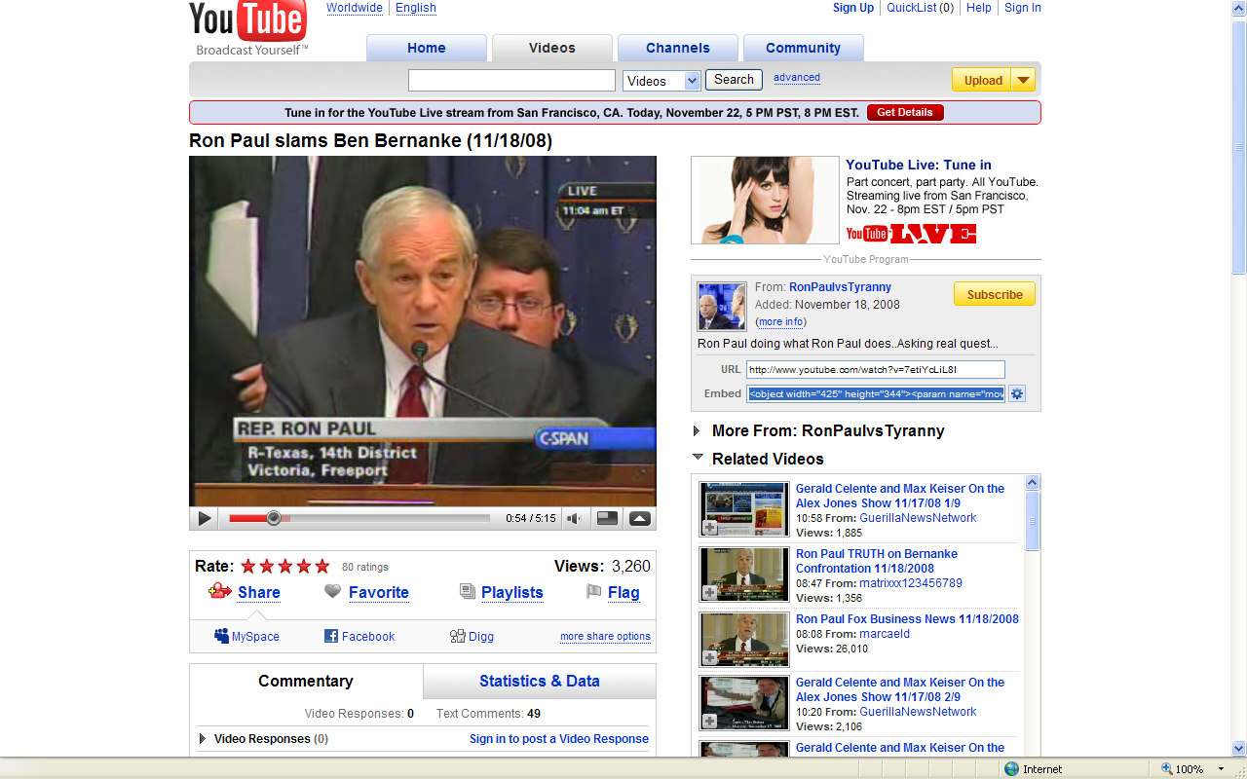
Paste YouTube Embed Code in the same way described in Section 1.1 Google Gadgets
Copy YouTube Embed Code

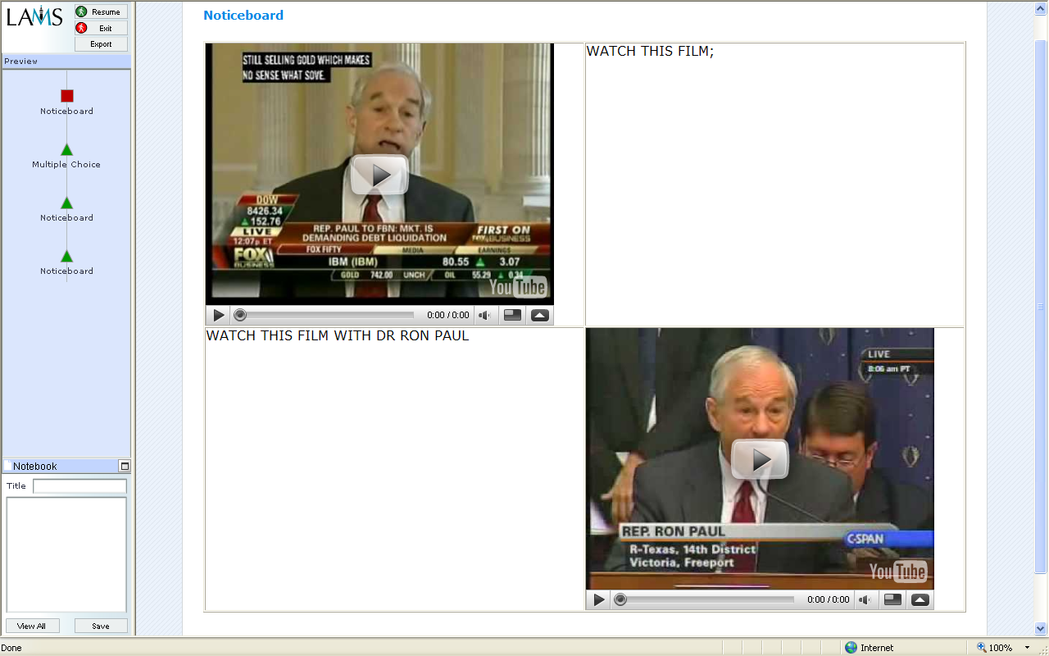
Learner view of 2 embedded YouTube films within a texted table

Figure 9 Embedding YouTube films

Embedding Films (within tables) requires basic knowledge computer codes; this may be a little complicated for non-computer savvy Authors. Also the embed codes are not directly available in Google Video.

1.6 Converting videos of teachers for flvPlayer use in LAMs.

The flvPlayer plugin uses the JW Media Player developed by Jeroen Wijering. The flvPlayer for the FCK Editor in LAMS, which is documented here, will allow the embedding of videos (using .flv files -Flash Video files) or sound (mp3 files) into activities. The use of teacher-recorded films in LAMS for Learners to view is a positive outcome of the flvPlayer plugin (see Figure 10). However, conversion of computer camera-recorded films to flv format may require the use of Any Video Converter or similar such video converters.

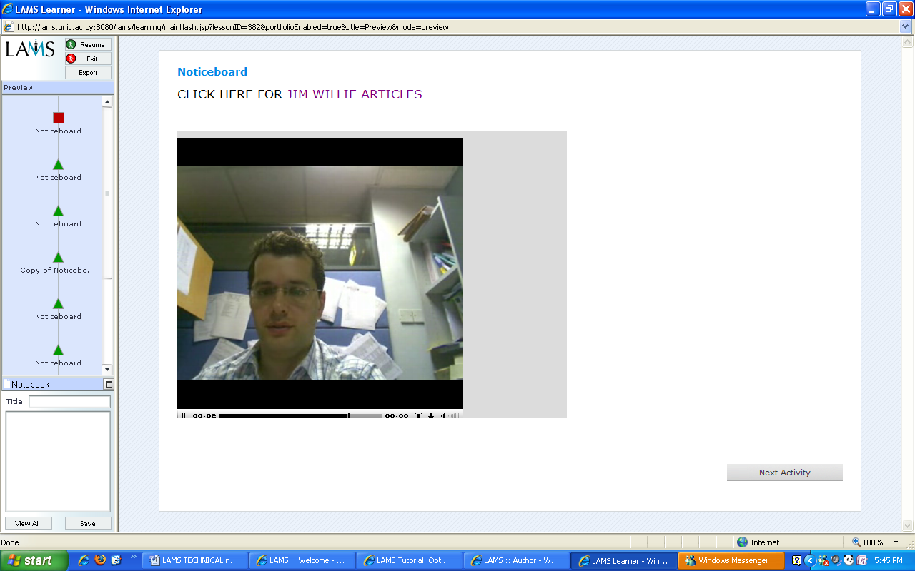
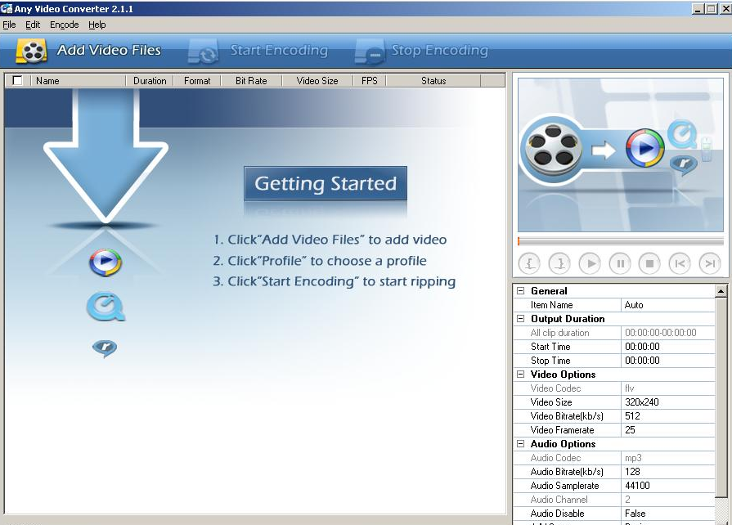
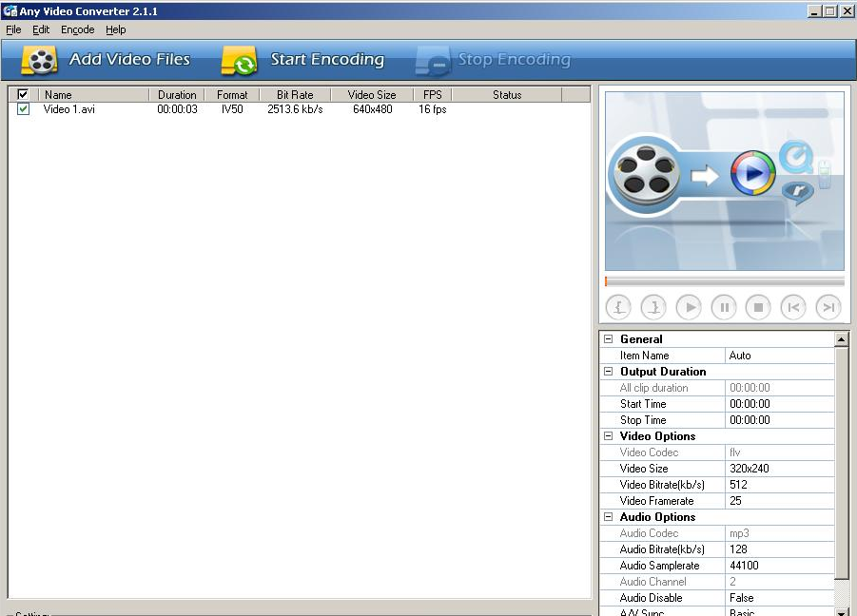
Convert video to flv format, save and upload to the LAMS server using the flv player on the FCK Editor

Use within sequences: example of Learner view

Figure 10 Teacher video use in LAMS (should) enhance the e-learning experience

The flvPlayer in LAMS is an additional installation that can appear in FCK Editor.
There are over 49000 thousand Google Gadgets
Fancy Noticeboard as used in James Dalziel’s Lesson Three LAMS Activities (available on LAMS Community)
http://www.marketoracle.co.uk and http://www.lifeaftertheoilcrash.net/BreakingNews.html
Any Video Converter is a professional video converter which can convert video files from various formats with fast converting speed and good video quality. It can convert almost all video formats including DivX, XviD, MOV, rm, rmvb, MPEG, VOB, DVD, WMV, AVI to MPEG-I, MPEG-I, DVD NTSC , DVD PAL, Flash for Video (FLV) ,AVI Video and Customized WMV movie formats. It also supports any user defined video file formats as the output.

